Practical 5
Problem Definition
Create a student registration form with HTML5 input types and JavaScript validation for name, email, mobile number, password, confirm password, course, year, gender, and terms acceptance. Use Regular Expression for validations.
Registration.html:-
<!DOCTYPE html>
<html lang="en">

<head>
<meta charset="UTF-8">
<meta name="viewport" content="width=device-width, initial-scale=1.0">

<title>StudentHub - Registration</title>

<link rel="stylesheet" href="css/style.css">
</head>

<body class="register">

<header>
<h1>Student Registration</h1>
</header>

<main>

<form id="registrationForm">

<label for="name">Full Name:</label>
<input type="text" id="name" placeholder="Enter your name">
<span id="nameError"></span>

<label for="email">Email:</label>
<input type="email" id="email" placeholder="Enter your email">
<span id="emailError"></span>

<label for="mobile">Mobile Number:</label>
<input type="tel" id="mobile" placeholder="Enter 10 digit mobile number">
<span id="mobileError"></span>

<label for="password">Password:</label>
<input type="password" id="password" placeholder="Enter password">
<span id="passwordError"></span>

<label>Password Strength:</label>
<progress id="strengthBar" value="0" max="3"></progress>
<span id="strengthText">Weak</span>

<label for="confirmPassword">Confirm Password:</label>
<input type="password" id="confirmPassword" placeholder="Confirm password">
<span id="confirmPasswordError"></span>

<label for="course">Course:</label>
<select id="course">
<option value="">Select Course</option>
<option value="CSE">Computer Science</option>
<option value="IT">Information Technology</option>
<option value="CE">Computer Engineering</option>
<option value="ME">Mechanical Engineering</option>
</select>
<span id="courseError"></span>

<label for="year">Year:</label>
<select id="year">
<option value="">Select Year</option>
<option value="1">1st Year</option>
<option value="2">2nd Year</option>
<option value="3">3rd Year</option>
<option value="4">4th Year</option>
</select>
<span id="yearError"></span>

<fieldset>
<legend>Gender:</legend>

<label>
<input type="radio" name="gender" value="Male">
Male
</label>

<label>
<input type="radio" name="gender" value="Female">
Female
</label>

<label>
<input type="radio" name="gender" value="Other">
Other
</label>
</fieldset>

<span id="genderError"></span>

<label>
<input type="checkbox" id="terms">
I agree to the terms and conditions
</label>

<span id="termsError"></span>

<button type="submit">Register</button>
<button type="reset">Clear</button>

<p id="successMessage"></p>

</form>

</main>

<script src="script.js"></script>

</body>

</html>

Screenshot:-
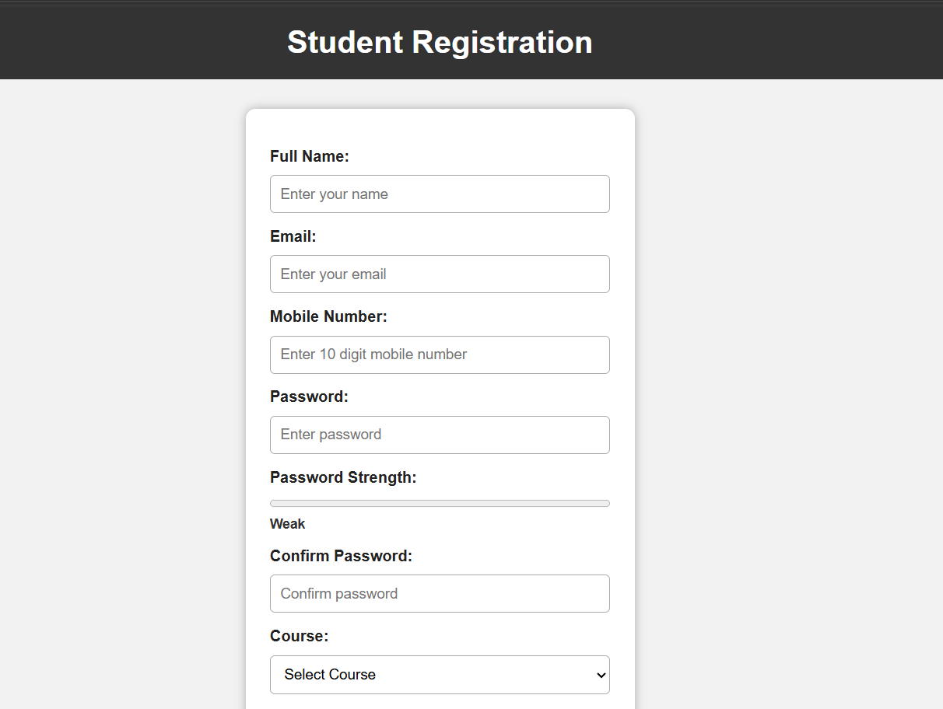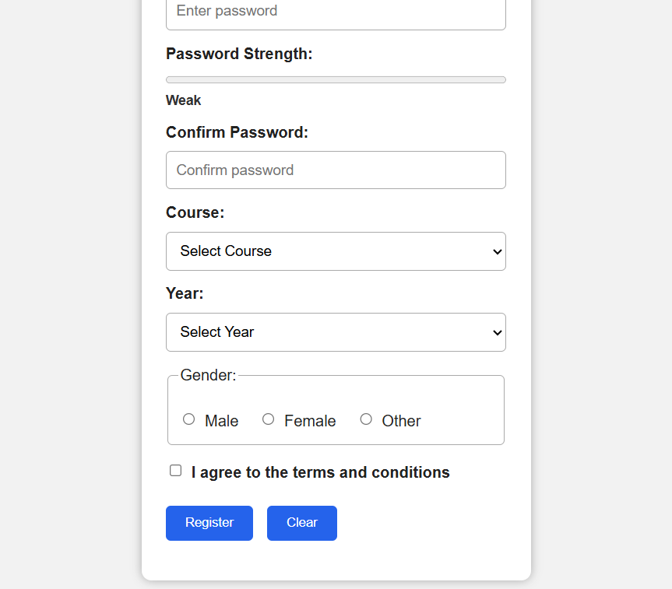
Login.html:-
<html lang="en">

<head>
<meta charset="UTF-8">
<meta name="viewport" content="width=device-width, initial-scale=1.0">

<title>StudentHub - Login</title>

<link rel="stylesheet" href="css/style.css">
</head>

<body class="login">

<header>
<h1>StudentHub Login</h1>
</header>

<main>

<form id="loginForm">

<h2>Login</h2>

<label for="email">Email:</label>
<input
type="email"
id="email"
placeholder="Enter your email"
required
>

<span id="emailError"></span>

<label for="password">Password:</label>
<input
type="password"
id="password"
placeholder="Enter your password"
required
>

<span id="passwordError"></span>

<label>
<input type="checkbox" id="remember">
Remember Me
</label>

<button type="submit">Login</button>

<p>
Don't have an account?
<a href="register.html">Register Here</a>
</p>

<p>
<a href="index.html">Back to Home</a>
</p>

<p id="loginMessage"></p>

</form>

</main>

<script>

const loginForm = document.getElementById("loginForm");

loginForm.addEventListener("submit", function(event) {

event.preventDefault();

let email = document.getElementById("email").value.trim();
let password = document.getElementById("password").value;

let emailError = document.getElementById("emailError");
let passwordError = document.getElementById("passwordError");
let loginMessage = document.getElementById("loginMessage");

emailError.textContent = "";
passwordError.textContent = "";
loginMessage.textContent = "";

let valid = true;

let emailPattern = /^[^\s@]+@[^\s@]+\.[^\s@]+$/;

if (email === "") {

emailError.textContent = "Email is required";
valid = false;

}
else if (!emailPattern.test(email)) {

emailError.textContent = "Enter a valid email";
valid = false;
}

if (password === "") {

passwordError.textContent = "Password is required";
valid = false;

}
else if (password.length < 6) {

passwordError.textContent =
"Password must contain at least 6 characters";

valid = false;
}

if (valid) {

loginMessage.textContent = "Login successful!";
loginMessage.style.color = "green";

setTimeout(function() {
window.location.href = "dashboard.html";
}, 1000);
}

});

</script>

</body>

</html>
Screenshot:-
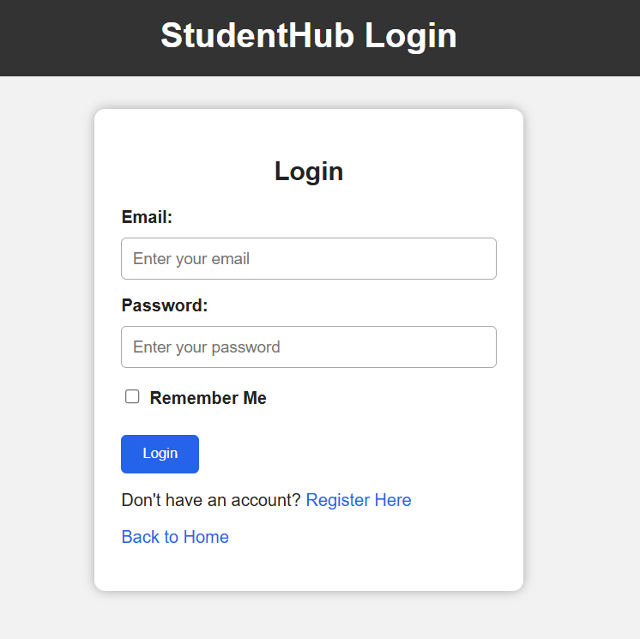
Script.js:-
const form = document.getElementById("registrationForm");

const password = document.getElementById("password");
const strengthBar = document.getElementById("strengthBar");
const strengthText = document.getElementById("strengthText");

password.addEventListener("input", function () {

let value = password.value;
let strength = 0;

if (value.length >= 6) {
strength++;
}

if (/[A-Z]/.test(value)) {
strength++;
}

if (/[0-9]/.test(value)) {
strength++;
}

strengthBar.value = strength;

if (strength <= 1) {
strengthText.textContent = "Weak";
}
else if (strength == 2) {
strengthText.textContent = "Medium";
}
else {
strengthText.textContent = "Strong";
}
});

form.addEventListener("submit", function (event) {

event.preventDefault();

document.querySelectorAll("span").forEach(function (span) {
span.textContent = "";
});

document.getElementById("successMessage").textContent = "";

let valid = true;

let name = document.getElementById("name").value.trim();
let email = document.getElementById("email").value.trim();
let mobile = document.getElementById("mobile").value.trim();
let passwordValue = document.getElementById("password").value;
let confirmPassword = document.getElementById("confirmPassword").value;
let course = document.getElementById("course").value;
let year = document.getElementById("year").value;
let terms = document.getElementById("terms").checked;

let namePattern = /^[A-Za-z ]+$/;

let emailPattern = /^[^\s@]+@[^\s@]+\.[^\s@]+$/;

let mobilePattern = /^[0-9]{10}$/;

if (name == "") {

document.getElementById("nameError").textContent =
"Name is required";

valid = false;
}

else if (!namePattern.test(name)) {

document.getElementById("nameError").textContent =
"Enter a valid name";

valid = false;
}

if (email == "") {

document.getElementById("emailError").textContent =
"Email is required";

valid = false;
}

else if (!emailPattern.test(email)) {

document.getElementById("emailError").textContent =
"Enter a valid email";

valid = false;
}

if (mobile == "") {

document.getElementById("mobileError").textContent =
"Mobile number is required";

valid = false;
}

else if (!mobilePattern.test(mobile)) {

document.getElementById("mobileError").textContent =
"Enter a valid 10 digit mobile number";

valid = false;
}

if (passwordValue == "") {

document.getElementById("passwordError").textContent =
"Password is required";

valid = false;
}

else if (passwordValue.length < 6) {

document.getElementById("passwordError").textContent =
"Password must contain at least 6 characters";

valid = false;
}

if (confirmPassword == "") {

document.getElementById("confirmPasswordError").textContent =
"Please confirm your password";

valid = false;
}

else if (passwordValue !== confirmPassword) {

document.getElementById("confirmPasswordError").textContent =
"Passwords do not match";

valid = false;
}
if (course == "") {

document.getElementById("courseError").textContent =
"Please select a course";

valid = false;
}
if (year == "") {

document.getElementById("yearError").textContent =
"Please select your year";

valid = false;
}

let gender = document.querySelector(
'input[name="gender"]:checked'
);

if (!gender) {

document.getElementById("genderError").textContent =
"Please select gender";

valid = false;
}
if (!terms) {

document.getElementById("termsError").textContent =
"You must accept the terms";

valid = false;
}

if (valid) {

document.getElementById("successMessage").textContent =
"Registration successful!";

alert("Registration successful!");

form.reset();

strengthBar.value = 0;
strengthText.textContent = "Weak";
}

});

const loginForm = document.getElementById("loginForm");

if (loginForm) {

loginForm.addEventListener("submit", function(event) {

event.preventDefault();

let email = document.getElementById("email").value.trim();
let password = document.getElementById("password").value;

let emailError = document.getElementById("emailError");
let passwordError = document.getElementById("passwordError");
let loginMessage = document.getElementById("loginMessage");

emailError.textContent = "";
passwordError.textContent = "";
loginMessage.textContent = "";

let valid = true;

let emailPattern = /^[^\s@]+@[^\s@]+\.[^\s@]+$/;

if (email === "") {

emailError.textContent = "Email is required";
valid = false;

} else if (!emailPattern.test(email)) {

emailError.textContent = "Enter a valid email";
valid = false;
}

if (password === "") {

passwordError.textContent = "Password is required";
valid = false;

} else if (password.length < 6) {

passwordError.textContent =
"Password must contain at least 6 characters";

valid = false;
}

if (valid) {

loginMessage.textContent = "Login successful!";
loginMessage.style.color = "green";

setTimeout(function() {

window.location.href = "dashboard.html";

}, 1000);
}

});

}

const registrationForm =
document.getElementById("registrationForm");

if (registrationForm) {

const password =
document.getElementById("password");

const strengthBar =
document.getElementById("strengthBar");

const strengthText =
document.getElementById("strengthText");

password.addEventListener("input", function() {

let value = password.value;
let strength = 0;

if (value.length >= 6) {
strength++;
}

if (/[A-Z]/.test(value)) {
strength++;
}

if (/[0-9]/.test(value)) {
strength++;
}

strengthBar.value = strength;

if (strength <= 1) {

strengthText.textContent = "Weak";

} else if (strength == 2) {

strengthText.textContent = "Medium";

} else {

strengthText.textContent = "Strong";
}

});

registrationForm.addEventListener("submit", function(event) {

event.preventDefault();

let valid = true;

let name =
document.getElementById("name").value.trim();

let email =
document.getElementById("email").value.trim();

let mobile =
document.getElementById("mobile").value.trim();

let passwordValue =
document.getElementById("password").value;

let confirmPassword =
document.getElementById("confirmPassword").value;

let course =
document.getElementById("course").value;

let year =
document.getElementById("year").value;

let terms =
document.getElementById("terms").checked;

let namePattern = /^[A-Za-z ]+$/;
let emailPattern = /^[^\s@]+@[^\s@]+\.[^\s@]+$/;
let mobilePattern = /^[0-9]{10}$/;

document.querySelectorAll("span").forEach(function(span) {
span.textContent = "";
});

if (name === "") {

document.getElementById("nameError").textContent =
"Name is required";

valid = false;

} else if (!namePattern.test(name)) {

document.getElementById("nameError").textContent =
"Enter a valid name";

valid = false;
}

if (email === "") {

document.getElementById("emailError").textContent =
"Email is required";

valid = false;

} else if (!emailPattern.test(email)) {

document.getElementById("emailError").textContent =
"Enter a valid email";

valid = false;
}

if (mobile === "") {

document.getElementById("mobileError").textContent =
"Mobile number is required";

valid = false;

} else if (!mobilePattern.test(mobile)) {

document.getElementById("mobileError").textContent =
"Enter a valid 10 digit mobile number";

valid = false;
}

if (passwordValue === "") {

document.getElementById("passwordError").textContent =
"Password is required";

valid = false;

} else if (passwordValue.length < 6) {

document.getElementById("passwordError").textContent =
"Password must contain at least 6 characters";

valid = false;
}

if (confirmPassword === "") {

document.getElementById("confirmPasswordError").textContent =
"Please confirm your password";

valid = false;

} else if (passwordValue !== confirmPassword) {

document.getElementById("confirmPasswordError").textContent =
"Passwords do not match";

valid = false;
}

if (course === "") {

document.getElementById("courseError").textContent =
"Please select a course";

valid = false;
}
if (year === "") {

document.getElementById("yearError").textContent =
"Please select your year";

valid = false;
}

let gender =
document.querySelector(
'input[name="gender"]:checked'
);

if (!gender) {

document.getElementById("genderError").textContent =
"Please select gender";

valid = false;
}

if (!terms) {

document.getElementById("termsError").textContent =
"You must accept the terms";

valid = false;
}
if (valid) {

document.getElementById("successMessage").textContent =
"Registration successful!";

document.getElementById("successMessage").style.color =
"green";

registrationForm.reset();

strengthBar.value = 0;
strengthText.textContent = "Weak";
}

});

}

loginForm.addEventListener("submit", function(event) {

event.preventDefault();

const name = document.getElementById("name").value.trim();
const phone = document.getElementById("phone").value.trim();
const email = document.getElementById("email").value.trim();
const password = document.getElementById("password").value;

const nameRegex = /^[A-Za-z ]{3,30}$/;
const phoneRegex = /^[6-9][0-9]{9}$/;
const emailRegex = /^[^\s@]+@[^\s@]+\.[^\s@]+$/;
const passwordRegex = /^(?=.*[A-Za-z])(?=.*\d)(?=.*[@$!%*?&]).{8,}$/;

document.getElementById("nameError").textContent = "";
document.getElementById("phoneError").textContent = "";
document.getElementById("emailError").textContent = "";
document.getElementById("passwordError").textContent = "";

let valid = true;

if (!nameRegex.test(name)) {
document.getElementById("nameError").textContent =
"Enter a valid name.";
valid = false;
}

if (!phoneRegex.test(phone)) {
document.getElementById("phoneError").textContent =
"Enter a valid 10 digit phone number.";
valid = false;
}

if (!emailRegex.test(email)) {
document.getElementById("emailError").textContent =
"Enter a valid email.";
valid = false;
}

if (!passwordRegex.test(password)) {
document.getElementById("passwordError").textContent =
"Password must be 8+ characters with letter, number and special character.";
valid = false;
}

if (valid) {
alert("Login Successful!");
loginForm.reset();
}
});

const themeButton = document.getElementById("themeButton");

themeButton.addEventListener("click", function() {

document.body.classList.toggle("dark-mode");

if (document.body.classList.contains("dark-mode")) {
themeButton.textContent = "Light Mode";
} else {
themeButton.textContent = "Dark Mode";
}

});

